HW using original dataset (matches paper tables)
Number of unique values of pid is 201
Number of records is 1357
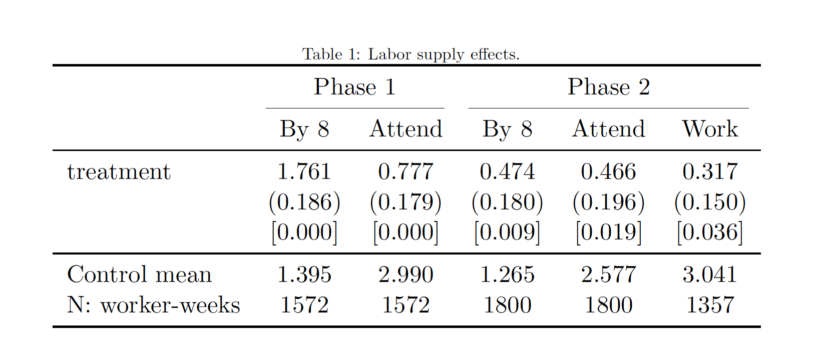

HW replication – prioritize in person
Number of unique values of pid is 205
Number of records is 1381
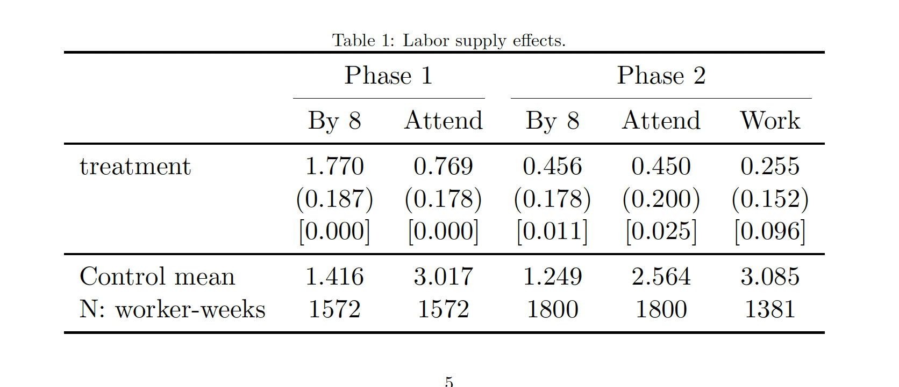
1381-1357 = 24 what explains these difference in pid-week observations??

Accounting for discrepancies
Summary:
- We have 29 pid-week_in’s only in new data but not in original.
  - Of these 29, 11 pid-week_ins belong to 4 pid’s that never appear in original dataset
- 5 pid-week_in’s only in original, but not in new data.
11+18-5 = 24
- PID only in new, not in original
- The following PID’s are only in new data: 604, 1511, 6826, 6889
- Of these, in the new data we have work data for:
  - 604: 6 weeks
  - 1511: 2 weeks
  - 6826: 2 weeks
  - 6889: 1 week
- Total: 11 pid-weeks
- PID only in original, not in new
- None
- PID-week_in only in new, not in original
- 11 pid have a week_in observations missing from original, for a total of 18 pid-week
- Additionally, we have 11 pid-weeks for PID’s that never appear in old (see point 1)
- Total: 11+18 = 29 pid-weeks
- PID-week_in only in original, not in new
- There are 5 pid with a week in original but not in main
- Total: -5

Define work1_wkly2

OLD
- Define if any in person recall exist in that week
- Define if any recall <= 7 exists in the week based on recall_length variable
- Consider reliable work if recall_length<=7 & recall mode == 1 (in person)
- Sum at week level the days of reliable work recall for weeks when there’s at least an in person recall and one recall < 7.
  - Issue: if all missing, replaced as 0 but it should be missing instead!!

PID-week_in only in original, not in new
- All due to coding issue replace 0 if all work (reliable) are missing
Correcting this would give us:
  - treatment = .3082521
  - P-value 0.042
  - Obs = 1,348
it affects 9 PID-weeks in phase 2
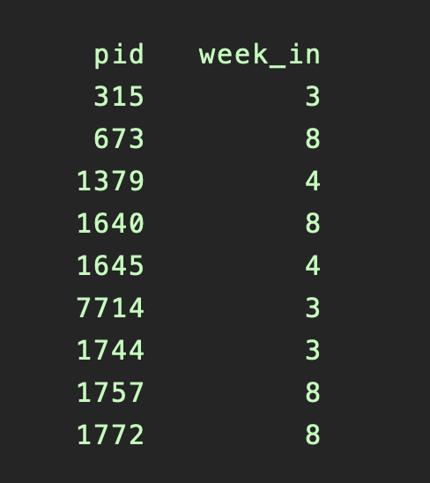
However, only 5 are missing from NEW.
Interestingly, the other 4 cases are week 8 observations. These are not missing in NEW because new data use recall from post week 8, which are instead missing from OLD.
Recall lag
work1_wkly2 Coefficient std. err. t P>t [95% conf. interval]
treatment .2710017 .1520826 1.78 0.076 -.0288536 .570857
Number of unique values of pid is 205
Number of records is 1375

/*
pid week_in
315 3
1379 4
1645 4
1744 3
7714 3
*/
Clarifications from Hao:
- When do we have a discrepancy between “prioritize in person” and “prioritize date”?
- How many observations?
- What’s recall source?
  - 1.
  - 2.
mode
- this is from the survey defines whether a recall grid was done in person (mode =1) or on the phone (mode=2).
- Then option 3 added

Steps:
- Start from x-section and define whether the x-section variables *_1 - *_7 are reliable or not and define the recall mode for the x-section variables
  - d_recall_reliable_`i' = 1 if recall grid on that day was done in person this means that Work_1 – work_7 is considered reliable
  - d_recall_source_`i' taks the value of the recall mode

* Gen Recall Type (i.e. if it is in person grid recall)
forval i = 1/7 {
gen d_recall_reliable_`i' = .
replace d_recall_reliable_`i' = 1 if mode == 1 & (!mi(d_work_`i') | !mi(d_main_act_work_`i'))
replace d_recall_reliable_`i' = 0 if mode == 2 & (!mi(d_work_`i') | !mi(d_main_act_work_`i'))
gen d_recall_source_`i' = .
replace d_recall_source_`i' = mode if (!mi(d_work_`i') | !mi(d_main_act_work_`i'))
}

Holidays
Nov 1, 2022
Note: Surveys were closed by 9:30 am, due to heavy rains
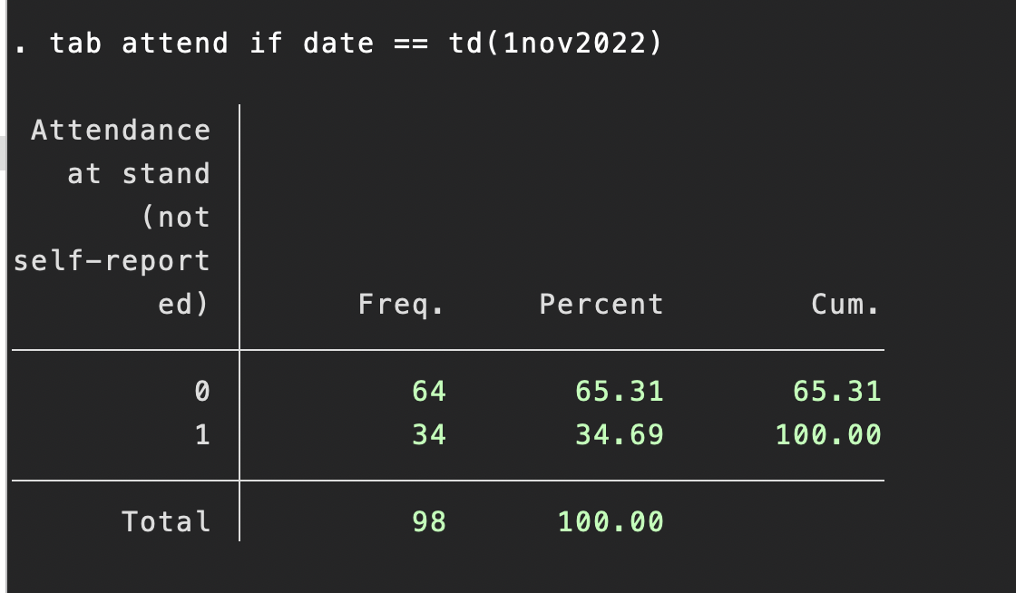

Nov 11, 2022

From notes: Only few surveyors reached the stand, and even there we have shut down the operation by 7:30, as red alert was issued
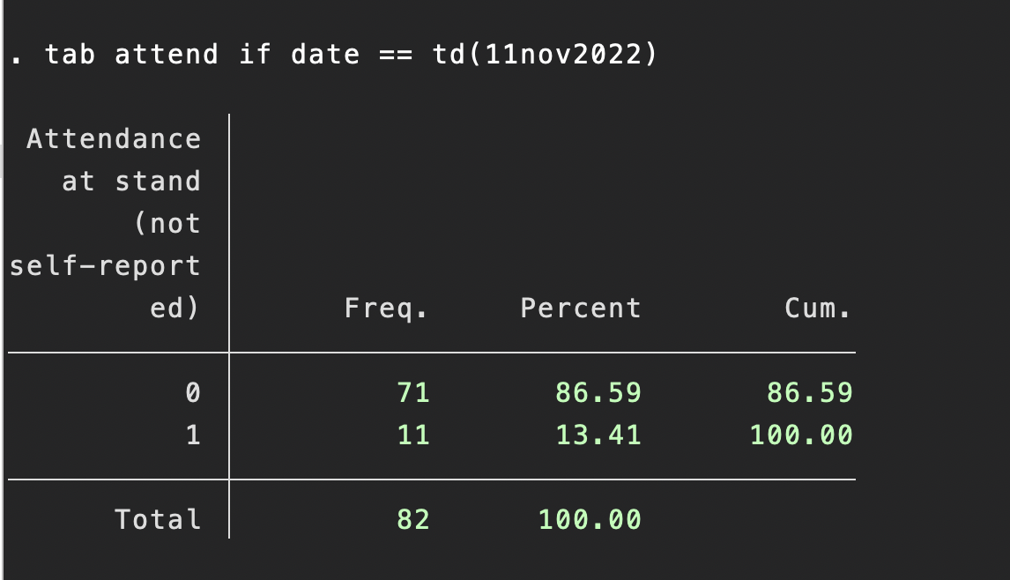
Nov 12, 2022
From notes: Field Operations was cancelled because of Red alert issued for Rain
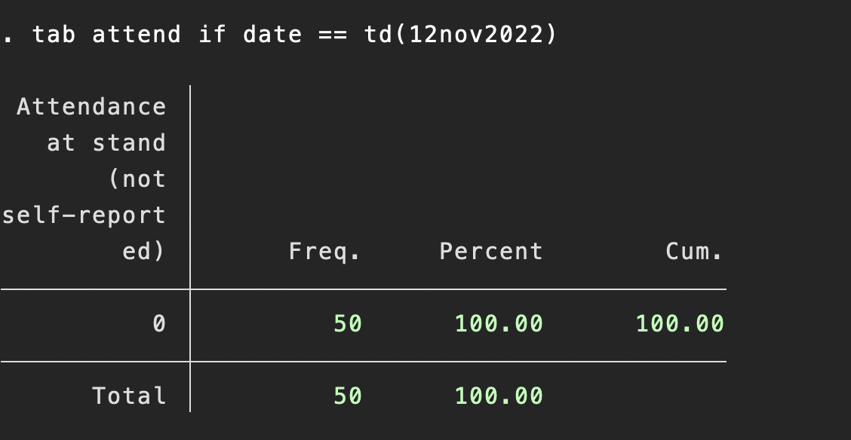

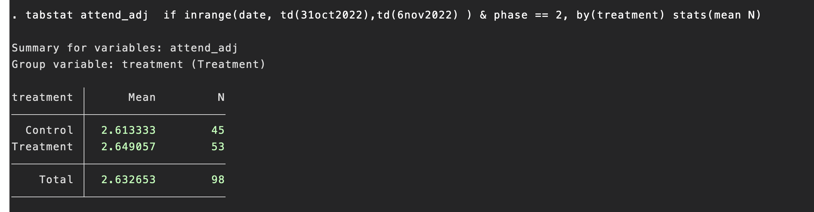
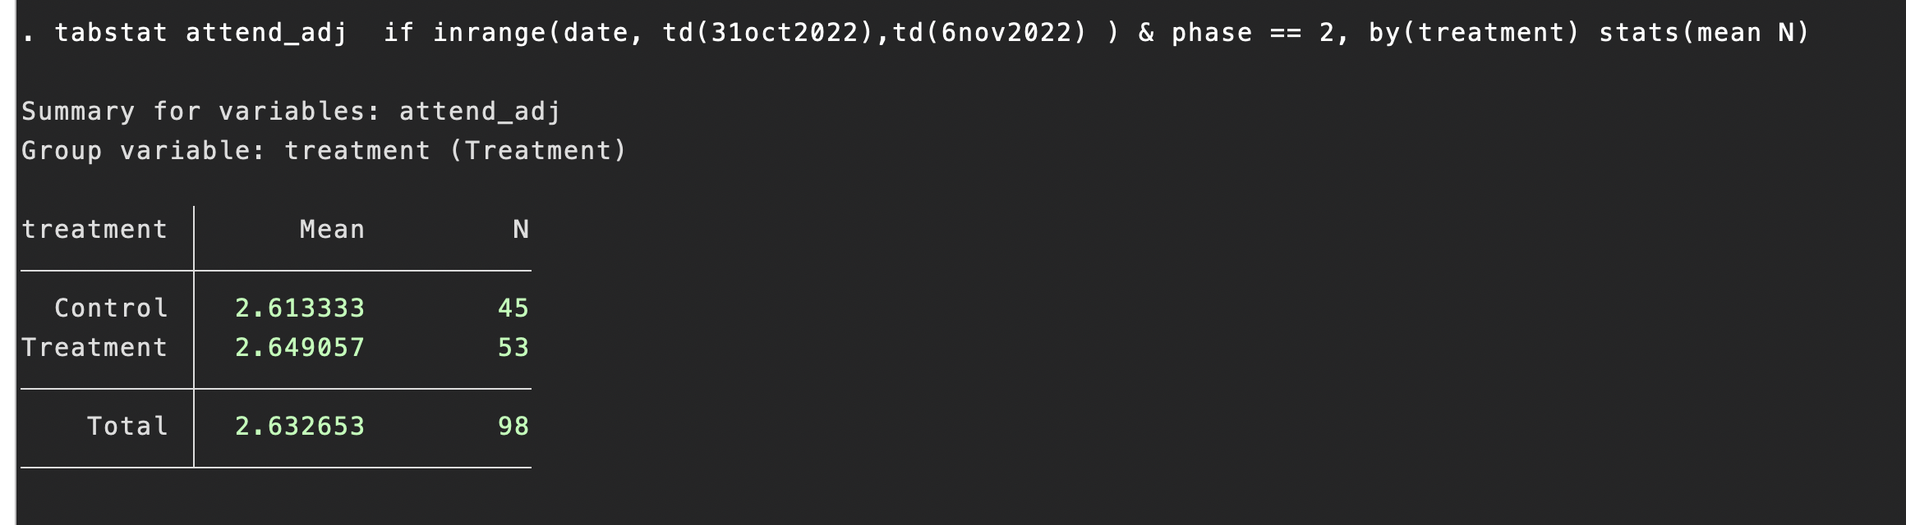
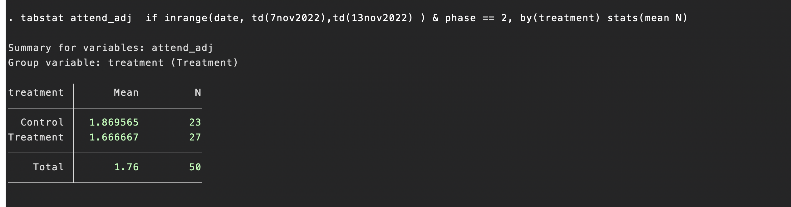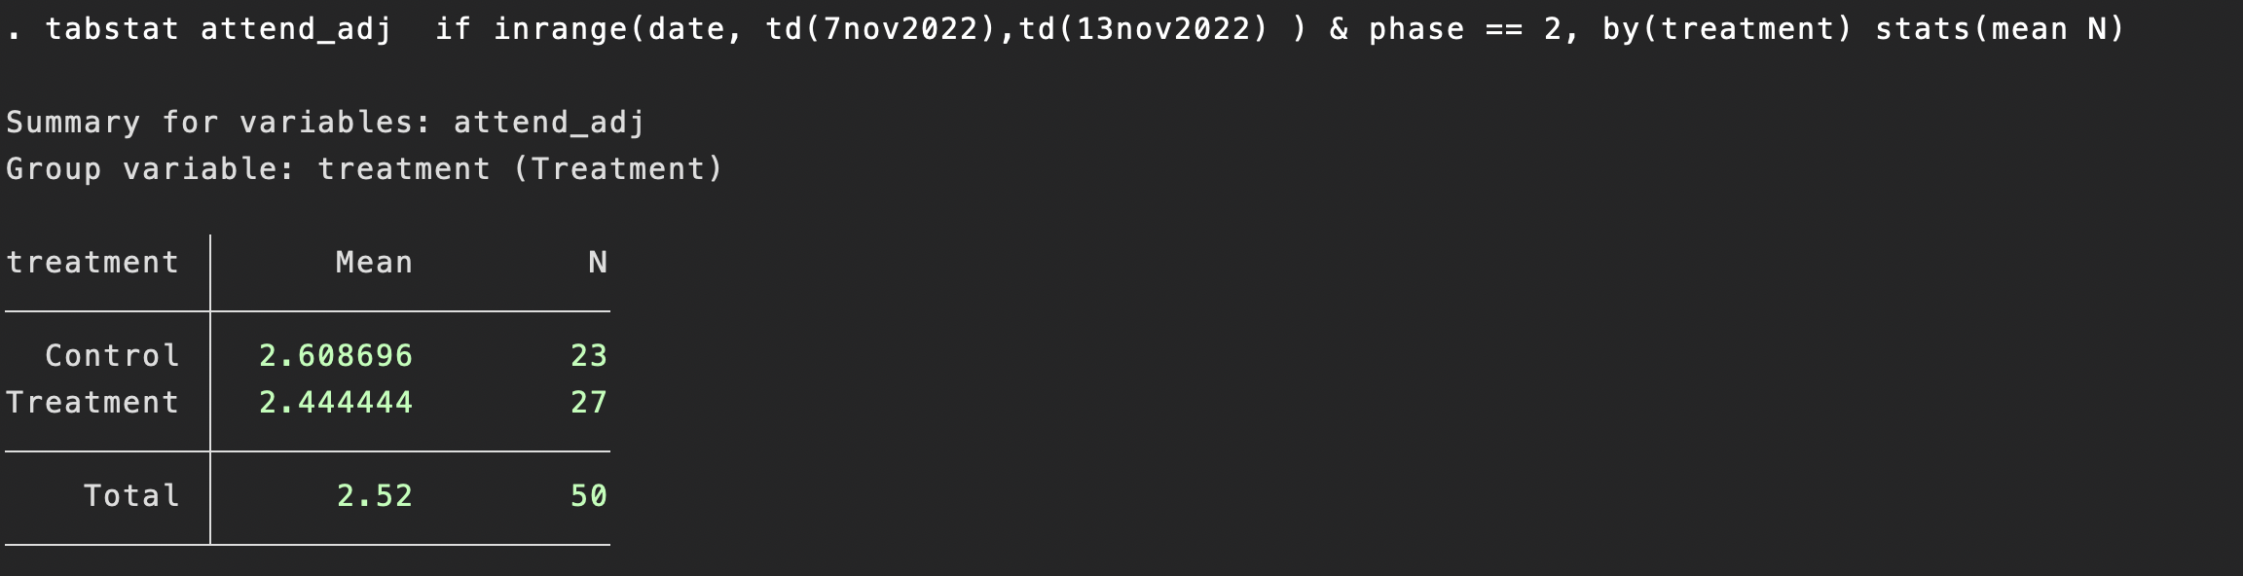
Phase 3
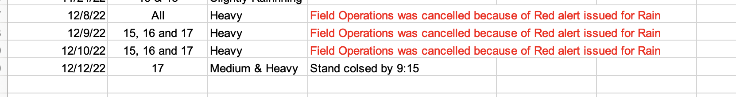
no Phase 3 survey data collected for dec 9, and 10 but we do have data for Dec 8 and 12.
Dec 8
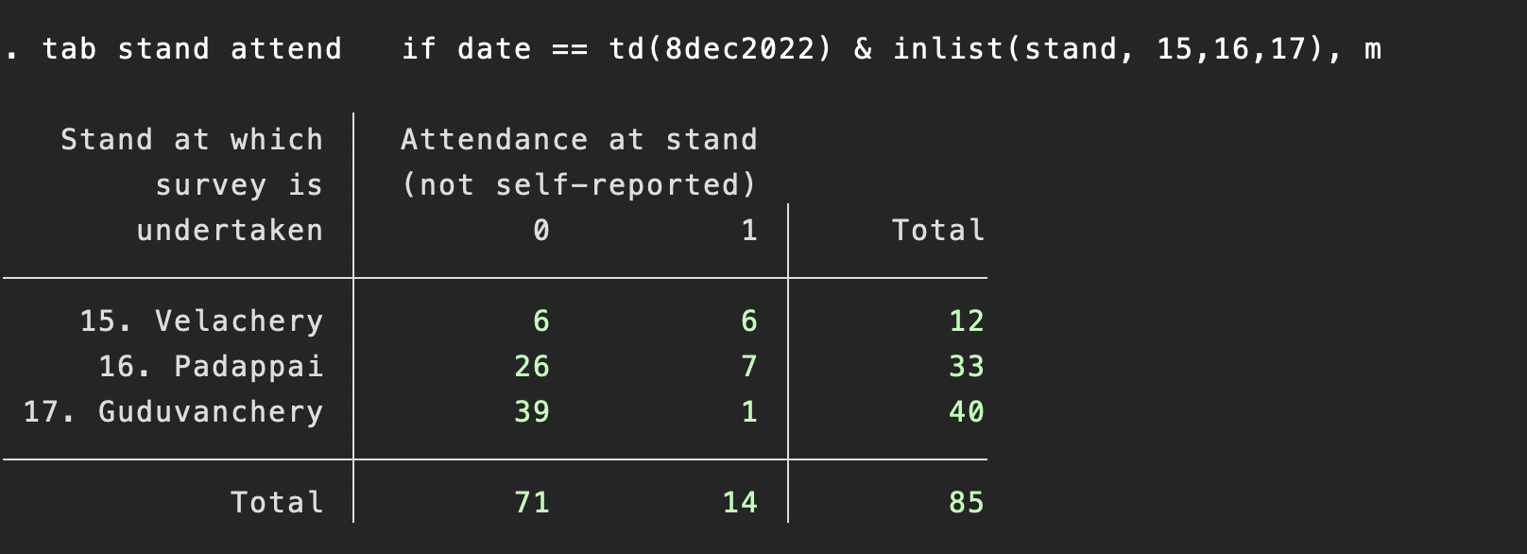
Dec 12
